 COMSATS University Islamabad, Lahore

FALL 2020
□ Sessional-1 □ Sessional-II □ Terminal Examination
Course Title: | Semantic Web (Theory) |  |  |  | Course Code: |  | CSE344 | Credit Hours: | 3(2,1)
Course Instructor/s: | Sana Rizwan |  |  |  | Program Name: |  | BSSE
Semester: | 7th | Batch: | FA17 | Section: | A/B/C |  | Date:
Time Allowed: | 2.5 Hours + 30 mins(submission) |  |  |  | Maximum Marks: |  |  | 50
Student’s Name: |  |  |  |  | Reg. No.
Important Instructions / Guidelines:
- All questions are compulsory.

Question: (Marks 5+5+4+5+4+6+6+3+4+3+5= 50)

1. Complete the diagram by writing missing technologies for the formation of OWL with numbering sequence.

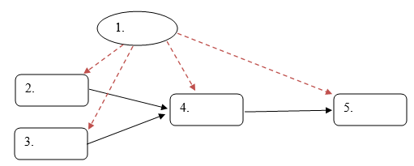

2. Consider the relationship between person and pet classes (e.g person has: pet animal, animal is_pet_of person)
Apply OWL reasoning inference on these facts and build the required predicates.
“Maano is the pet of Ali”

3. Write differences between both.

RDFa | Microformat
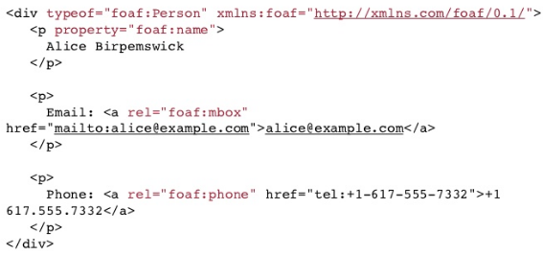 | 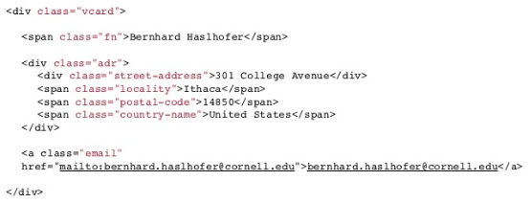

4. During scanning the Web, three documents were found which contain information about Peter in Person OWL ontology having three address in return, however only one can be correct:

i. <Person rdf:about="http://www.person.org#Peter">
<address rdf:about="http://www.states.org#Newyork"/>
</Person>
ii. <Person rdf:about="http://www.person.org#Peter">
< address rdf:resource="http://www.history.org#Newjersey"/>
</Person>
iii. <Person rdf:about="http://www.person.org# Peter ">
<address rdf:resource="http://www.tourism.org#California"/>
</Person>

What is the address of Peter, answer carefully by using inference, give reasons and discuss its cardinality?

5. State data principles that link data publishers on semantic web.

6. Write OWL coding structure to describe logical inferences.

i. Animals ≡ Mammals ⊔ Amphibians ⊔ Reptiles ⊔ Birds ⊔ Fish
ii. Range Rover ≡ Cars ⊓ 4WD
iii. Fabric ≡ {Leather, Cotton, Silk, Chiffon}

7. Write OWL property restriction coding structure to describe logical inferences.

i. Vertebrates ⊑ Reptiles ⊓ ∃hastail.Animals
ii. K ⊑ U ⊓ ∀hasAlphabets.W (Whereas, W = whole numbers, U = Universal set, K = Alphabet)
iii. CarldonChildren ⊑ Person П ∃hasParent.{CARLDON}

8. Make flow chart of GRDDL process by the help of structuring data.

9. Write RDFa coding pattern for the visualization of structured data given below.

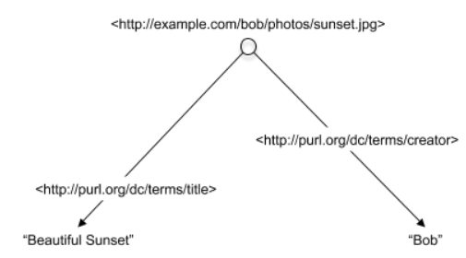

10. State the three dialects of RIF.

11. Identify SUBJECT, PREDICATE and OBJECT by the given table.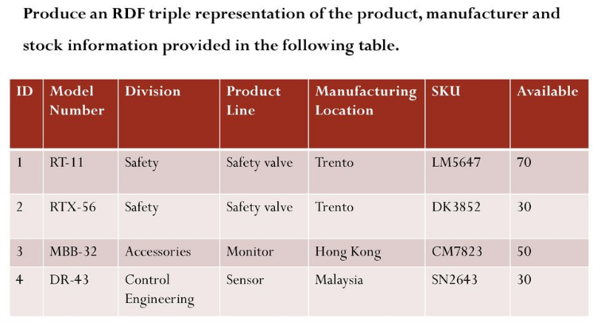

BEST OF LUCK

Solution:

1. Complete the diagram by writing missing technologies for the formation of OWL with numbering sequence.



Answer:

1. RDF
2. OIL
3. DAML
4. DAML + OIL
5. OWL

2. Consider the relationship between person and pet classes (e.g person has: pet animal, animal is_pet_of person)
Apply OWL reasoning inference on these facts and build the required predicates.
“Maano is the pet of Ali”
Answer:

Here is an interaction between an inverse relationship and domain and range constraints on a property.
- Maano is the pet of Ali
- So Ali has pet Maano
- Ali must be a Person
- Maano must be an Animal
Individual(a:Maano type(owl:Thing)
value(a:is_pet_of a:Ali))
Individual(a:Ali
type(owl:Thing))
ObjectProperty(a:has_pet domain(a:person) range(a:animal))
ObjectProperty(a:is_pet_of inverseOf(a:has_pet))

3. Write differences between both.

RDFa | Microformat
 | 

Answer:
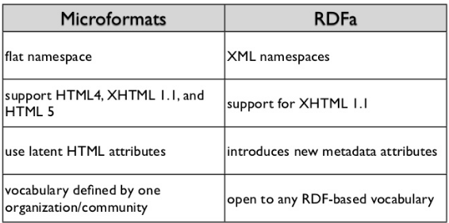

4. During scanning the Web, three documents were found which contain information about Peter in Person OWL ontology having three address in return, however only one can be correct:

i. <Person rdf:about="http://www.person.org#Peter">
<address rdf:about="http://www.states.org#Newyork"/>
</Person>
ii. <Person rdf:about="http://www.person.org#Peter">
< address rdf:resource="http://www.history.org#Newjersey"/>
</Person>
iii. <Person rdf:about="http://www.person.org# Peter ">
<address rdf:resource="http://www.tourism.org#California"/>
</Person>

What is the address of Peter, answer carefully by using inference, give reasons and discuss its cardinality?

Answer:

The Person OWL Ontology indicates that a Person has only one birthplace location:

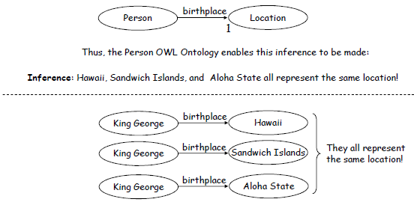
In the example we saw that the Person Ontology defined this relationship:
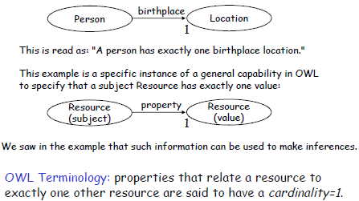

5. State data principles that link data publishers on semantic web.

Answer:
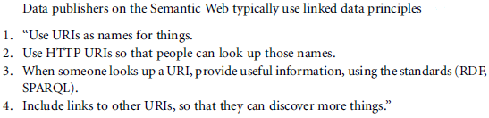

6. Write OWL coding structure to describe logical inferences.

i. Animals ≡ Mammals ⊔ Amphibians ⊔ Reptiles ⊔ Birds ⊔ Fish

Answer:
<owl:Class rdf:ID=“Animals">
<owl:unionOf rdf:parseType="Collection">
<owl:Class rdf:about="#Mammals" />
<owl:Class rdf:about="#Amphibians" />
<owl:Class rdf:about="#Reptiles" />
<owl:Class rdf:about="#Birds" />
<owl:Class rdf:about="#Fish" />
</owl:unionOf>
</owl:Class>

ii. Range Rover ≡ Cars ⊓ 4WD

Answer:
<owl:Class rdf:ID=“Range Rover">
<owl:intersectionOf rdf:parseType="Collection">
<owl:Class rdf:about="#Cars" />
<owl:Class rdf:about="#4WD" />
</owl:intersectionOf>
</owl:Class>

iii. Fabric ≡ {Leather, Cotton, Silk, Chiffon}

Answer:
<owl:Class rdf:ID="Fabric">
<rdfs:subClassOf rdf:resource="#FabricDescriptor"/>
<owl:oneOf rdf:parseType="Collection">
<owl:Thing rdf:about="#Leather"/>
<owl:Thing rdf:about="#Cotton"/>
<owl:Thing rdf:about="#Silk"/>
<owl:Thing rdf:about="#Chiffon"/>
</owl:oneOf>
</owl:Class>

7. Write OWL coding structure to describe logical inferences.

i. Reptiles ⊑ Vertebrates ⊓ ∃hastail.Animals

Answer:
<owl:Class rdf:ID=“Reptiles">
<rdfs:subClassOf rdf:resource="#Vertebrates" />
<rdfs:subClassOf>
<owl:Restriction>
<owl:onProperty rdf:resource="#hastail" />
<owl:someValuesFrom rdf:resource="#Animals" />
</owl:Restriction>
</rdfs:subClassOf>
</owl:Class>

ii. K ⊑ U ⊓ ∀hasAlphabets.W (Whereas, W = whole numbers, U = Universal set, K = Alphabet)

Answer:
<owl:Class rdf:ID=“K">
<rdfs:subClassOf rdf:resource="#U" />
<rdfs:subClassOf>
<owl:Restriction>
<owl:onProperty rdf:resource="#hasAlphabets" />
<owl:allValuesFrom rdf:resource="#W" />
</owl:Restriction>
</rdfs:subClassOf>
...
</owl:Class>

iii. CarldonChildren ⊑ Person П ∃hasParent.{CARLDON}

Answer:
<owl:Class rdf:ID=“CarldonChildren">
<rdfs:subClassOf rdf:resource="#Person" />
<rdfs:subClassOf>
<owl:Restriction>
<owl:onProperty rdf:resource="#hasParent" />
<owl:hasValue rdf:resource="#CARLDON" />
</owl:Restriction>
</rdfs:subClassOf>
</rdfs:subClassOf>
...
</owl:Class>

8. Make flow chart of GRDDL process by the help of structuring data

Answer:
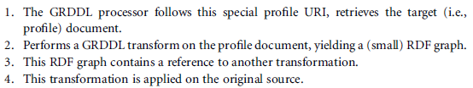
- XHTML (A1[CSE344]--URI) microformats (processors -- Transformation) XML RDF Logic(OWL) Ontology web site (Resources) microformats (GRDDL/RDFa) XML
- XHTML (A2[CDE456] -- URI)

9. Write RDFa coding pattern for the visualization of structured data given below.



Answer:

<div resource="/alice/posts/trouble_with_bob">
<h2 property="title">The trouble with Bob</h2>
...
The trouble with Bob is that he takes much better photos than I do:
...
<div resource="http://example.com/bob/photos/sunset.jpg">
<img src="http://example.com/bob/photos/sunset.jpg" />
<span property="title">Beautiful Sunset</span>
by <span property="creator">Bob</span>.
</div>
</div>

10. State the three dialects of RIF.

Answer:
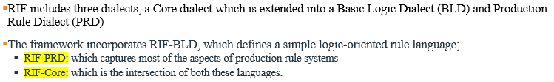

11. Identify SUBJECT, PREDICATE and OBJECT by the given table.

Answer:
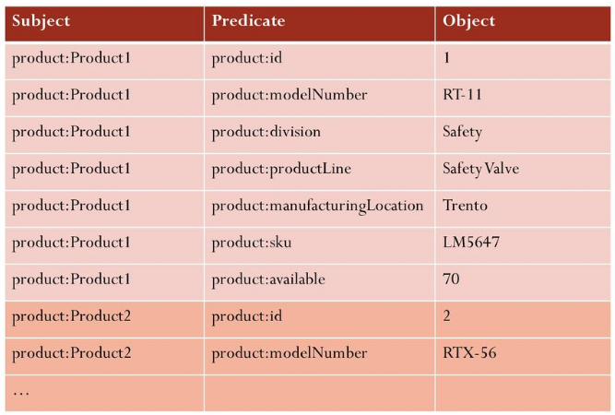

BEST OF LUCK

